Electric Vehicle Market Evolution in the USA (2050)
Numerical Methods for Economic Systems

Contents
1. General data about the United States 1
2. Initial hypothesis 1
3. Economic factors 2
4. Social and legal factors 3
5. Technological factors 4
6. Integration and final prediction 6
7. Conclusion 8
References 8

1. General data about the United States
The United States is the world’s largest economy with a GDP of $27.72 trillion (2023) and a population of 340.1 million. Per capita GDP of approximately $83,000 creates favorable conditions for premium EV adoption despite higher upfront costs. The country has approximately 290 million registered vehicles with annual new vehicle sales of around 16 million units. Transportation generates 27% of U.S. greenhouse gas emissions – approximately 1.9 billion tons CO₂ annually – making it the largest emissions source, surpassing electricity generation (25%) and industry (23%). Light-duty vehicles account for 58% of transportation emissions (1.1 billion tons), driven by high per-capita vehicle miles (12,000 annually) and preference for larger, less efficient vehicles. This positions vehicle electrification as essential for meeting climate goals.
The U.S. possesses structural advantages for EV adoption. Renewable energy now comprises 22% of electricity generation (up from 13% in 2013), with natural gas providing another 40%. This cleaner grid means EVs already achieve 60-70% lower lifecycle emissions than gasoline vehicles, with benefits expanding as renewables grow. Domestic resources include copper and lithium reserves, though the U.S. currently imports 80% of lithium and depends heavily on China for processed battery materials and rare earth elements. Recent policies like the Inflation Reduction Act aim to reduce these dependencies through supply chain diversification and domestic manufacturing incentives.

2. Initial hypothesis
Electric vehicle adoption in the United States began in earnest in 2011 with the introduction of the Nissan Leaf and Chevrolet Volt. From modest beginnings of just 17,800 units in 2011, the market has grown dramatically to 1.39 million units in 2023, representing a compound annual growth rate (CAGR) of approximately 43.5% over this period.
The initial forecast model uses a logistic (S-curve) function, which is typical for technology adoption patterns. This approach assumes that EV adoption will follow an S-shaped curve with slow initial growth, followed by rapid acceleration, and eventually a plateau as the market approaches saturation.
We built our forecast using as a baseline the 3-parameter logistic curve
$$S\left(t\right)=\frac{K}{1+e^{-r \left(t-t_{0}\right)}}$$
calibrated to 2011-2023 U.S. data.
Parameter | Symbol | Value | Rationale
Carrying capacity | K | 12 million vehicles / year | ~80 % of today’s 16 M total light-duty vehicle (LDV) market
Growth rate | r | 0.20 year⁻¹ | Steep enough to hit majority adoption by mid-2030s, matches China/Norway midpoint slopes
Inflection year | t₀ | 2035 | Year when EVs cross ~6 M units/yr (50 % of new LDV sales)

3. Economic factors
Economic factors play a crucial role in EV adoption rates. Our analysis incorporates several key economic variables:
Battery costs represent approximately 30% of EV retail prices and have been declining steadily. From approximately $120/kWh in 2023, we project costs will follow a sigmoid decline toward an asymptotic floor of $50/kWh by the mid-2040s. This decline directly impacts vehicle affordability and consequently adoption rates.
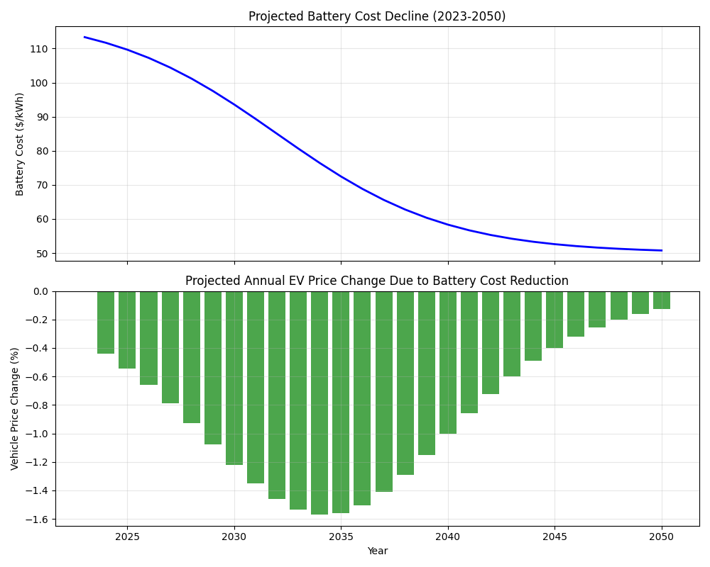
The model incorporates GDP growth projections with a mean annual growth rate of 1.8% and standard deviation of 1.0%. Economic growth affects purchasing power and vehicle affordability, with an elasticity factor of 0.8 (meaning a 1% increase in GDP corresponds to a 0.8% increase in EV demand, all else equal).
Consumer response to price changes is modelled with a price elasticity of 1.1, indicating that a 1% decrease in EV prices corresponds to a 1.1% increase in demand. This elasticity factor is applied to the price changes resulting from battery cost reductions.
The current economic environment is characterized by increased volatility due to:
- Trade tensions and tariff policies affecting supply chains
- Inflation pressures and monetary policy responses
- Stock market fluctuations impacting consumer confidence
- Global supply chain disruptions
These factors create a “fog of war” effect that increases uncertainty in forecasts. Our model addresses this through Monte Carlo simulations that incorporate this uncertainty, producing not just median projections but also confidence intervals (10-90% ranges) for each scenario.

4. Social and legal factors
Government policies and social attitudes significantly influence EV adoption. Our analysis incorporates the following key policy events and their projected impacts:
Federal Incentives:
- Federal Tax Credit Phase-Down (2024): The gradual reduction of federal incentives creates a slight headwind (-2% impact) in the near term.
- Federal 100% ZEV Mandate (2040): A potential federal zero-emission vehicle mandate would create a significant step-change in adoption (+10% impact).
State Policies:
- Multiple States Adopt California ZEV Standards (2026): As more states align with California’s regulations, this creates a moderate boost (+3% impact).
- Several States 100% ZEV Mandate (2035): State-level mandates for 100% zero-emission vehicles create a substantial acceleration (+7% impact).
Infrastructure and Carbon Policy:
- Infrastructure Investment Peaks (2028): Major investments in charging infrastructure remove adoption barriers (+2% impact).
- Carbon Pricing Introduction (2030): The introduction of carbon pricing mechanisms creates economic incentives for EV adoption (+5% impact).
The cumulative impact of these policies creates distinct step changes in the adoption curve, particularly visible in the updated model that explicitly incorporates these discrete events. The timing and magnitude of these policies vary significantly across scenarios, with the GreenSurge scenario featuring stronger and earlier policy implementation, while the StallOut scenario features weakened or delayed policies.
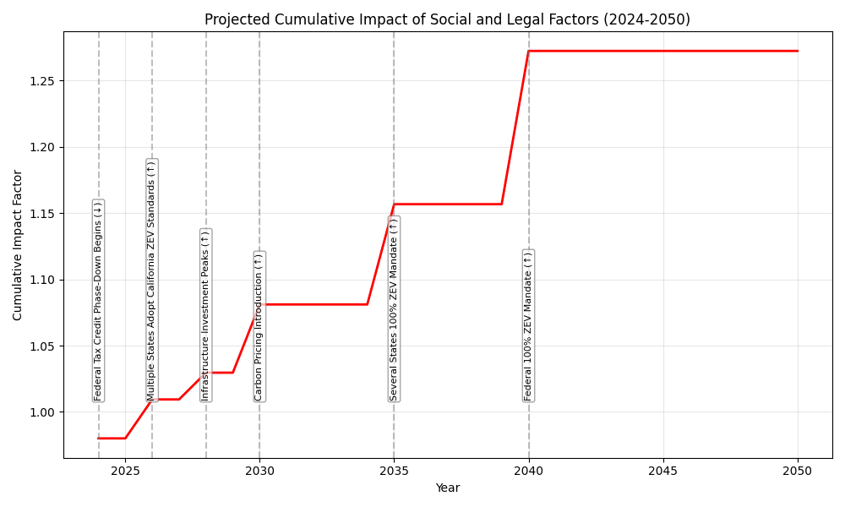

5. Technological factors
Technological developments significantly influence EV adoption rates. Our analysis incorporates the following key technological factors and their projected impacts:
Manufacturing and Production:
- Car Production Efficiency (+7.5%): Improvements in manufacturing processes, automation, and scale economies reduce production costs and increase availability.
- Components/Parts Manufacturing (+2.5%): Advancements in the supply chain for EV-specific components improve reliability and reduce costs.
- AI in Manufacturing (+3.0%): Artificial intelligence applications in production planning, quality control, and process optimization enhance efficiency.
Battery and Charging Technology:
- Battery Technology Improvements (+4.5%): Advancements in chemistry, energy density, and manufacturing processes improve range and reduce costs.
- Charging Infrastructure (+3.5%): Expansion and technological improvements in charging networks reduce range anxiety and improve convenience.
Competing and Supporting Technologies:
- Hydrogen Technologies Competition (-5.0%): Development of hydrogen fuel cell vehicles may divert some investment and adoption from battery EVs.
- Smart Cities Development (+2.5%): Integration of EVs with smart city infrastructure creates synergies and incentives for adoption.
- Grid Modernization (+2.0%): Improvements in electrical grid capacity, reliability, and smart features support EV charging needs.
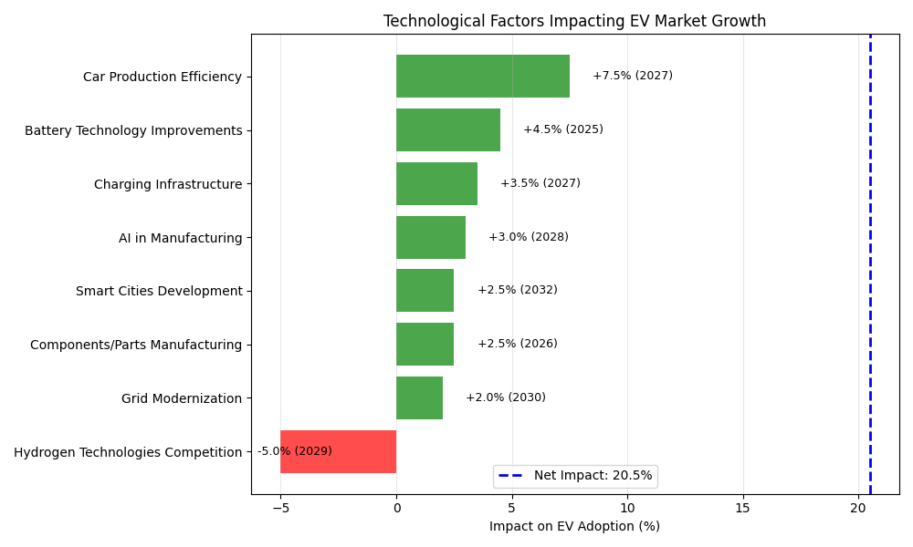

Below is a comparison of the individual impact of four selected factors on annual EV sales:
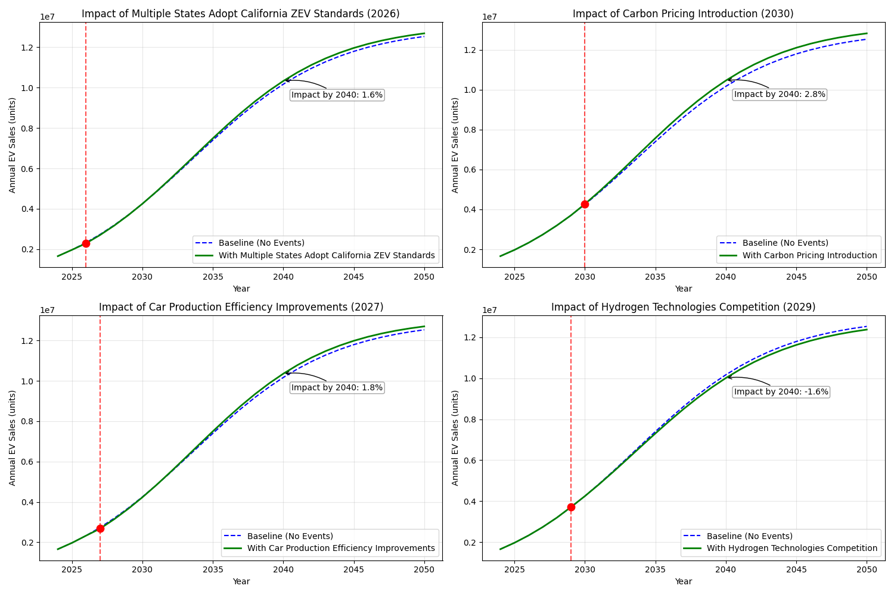

6. Integration and final prediction
The model, run for 1000 simulations, explicitly integrates all economic, social, legal, and technological factors as discrete events with specific timing and impact magnitudes. This approach creates a more realistic forecast that clearly shows step changes and inflection points corresponding to major policy implementations and technological breakthroughs.
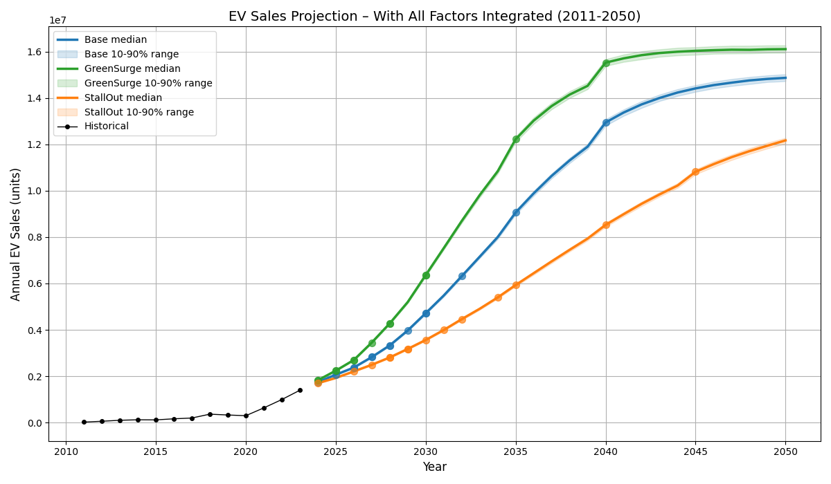
The Monte Carlo simulation produced the following results:
- Base Scenario: Represents the most likely path given current trends and moderate implementation of policies and technological developments. Projects 14.8 million annual EV sales by 2050 (approximately 90% of total vehicle market).
- GreenSurge Scenario: Assumes accelerated policy implementation, stronger incentives, and faster technological development. Projects 16.1 million annual EV sales by 2050 (the whole light-duty vehicle market).
- StallOut Scenario: Assumes weakened or reversed policies, delayed technological development, and economic headwinds. Projects 12.1 million annual EV sales by 2050 (approximately 80% of total vehicle market).
The annual growth rate analysis shows rapid growth in the near term (2024-2030) across all scenarios, with rates exceeding 15% annually. Growth rates gradually decline as the market matures, dropping below 10% in all scenarios at almost the same time by 2036.
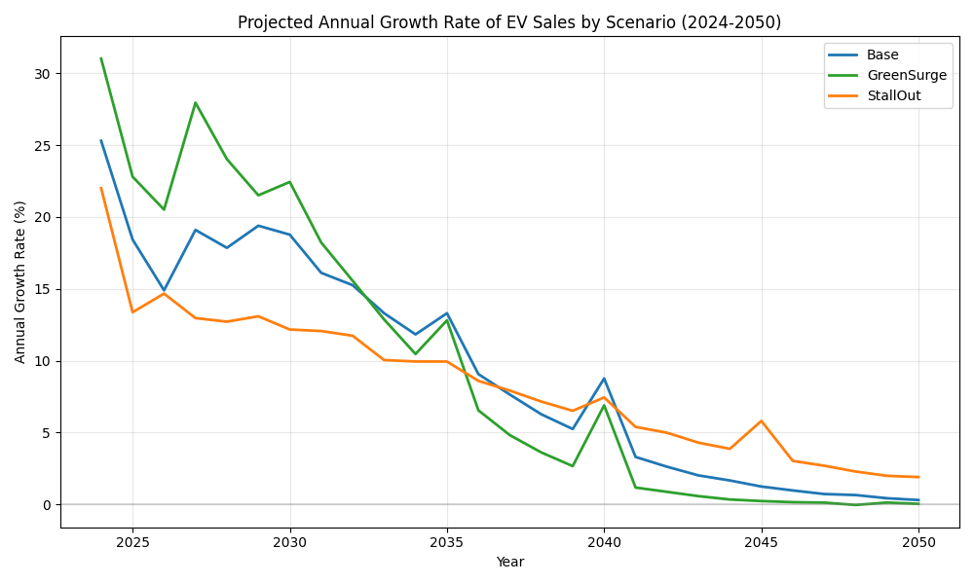
Market share projections indicate that EVs will reach 50% of new vehicle sales in the Base scenario by 2034, in the GreenSurge scenario by 2032, and in the StallOut scenario by 2040. Full market saturation (100%) is almost reached in the GreenSurge scenario from 2040, while it is not reached in the other scenarios.
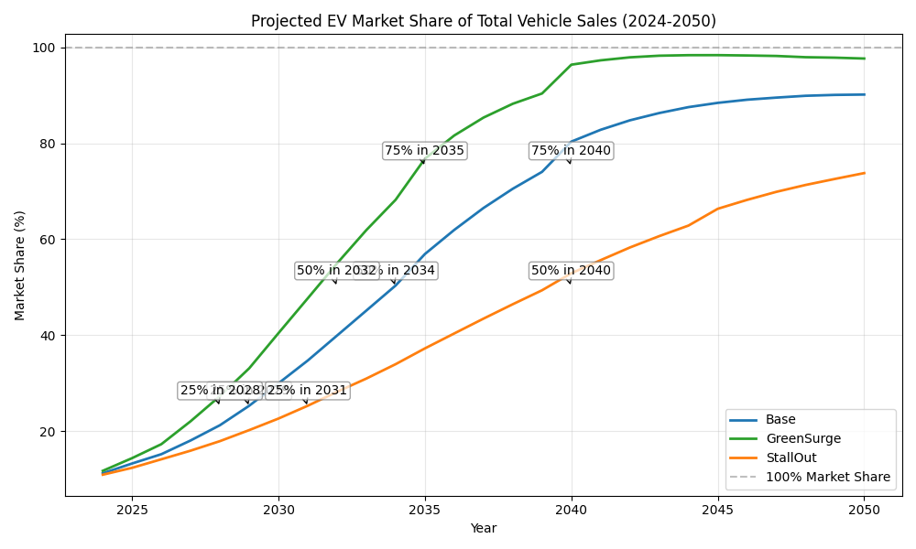
The sensitivity analysis reveals that policy factors generally have larger individual impacts than technological factors, with the Federal 100% ZEV Mandate (+5.3%) and Several States 100% ZEV Mandate (+4.2%) having the largest positive impacts. Among technological factors, Car Production Efficiency (+3.2%) and Battery Technology Improvements (+2.1%) have the most significant positive impacts, while Hydrogen Technologies Competition (-2.1%) represents the largest negative factor.
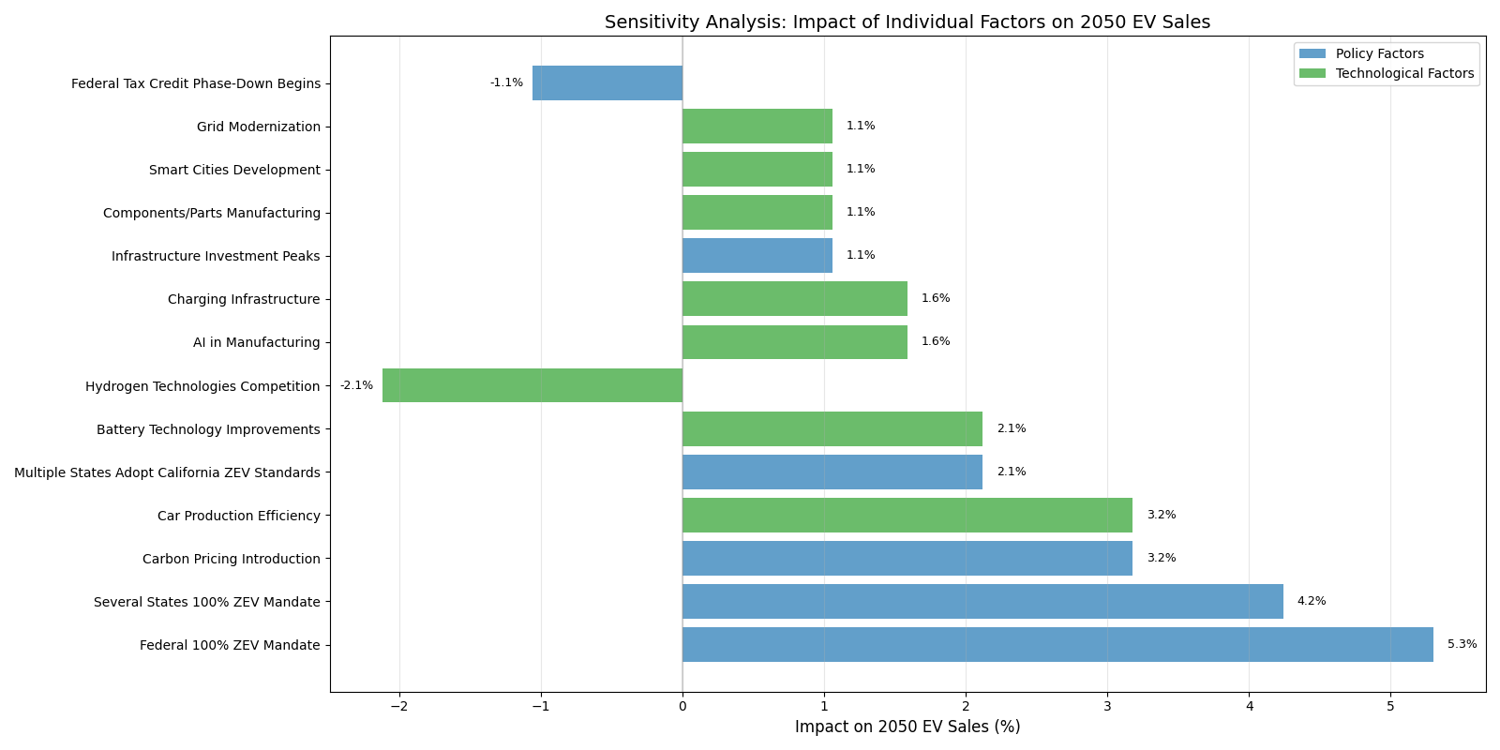

7. Conclusion
The step-change nature of the forecast model, showing discrete jumps rather than smooth curves, reflects market reality more accurately than traditional logistic projections. EV adoption doesn’t follow predictable patterns – it responds to specific policy implementations, infrastructure milestones, and technological breakthroughs that create sudden shifts in consumer behavior and industry investment.
The analysis makes clear that achieving 11-12 million annual EV sales by 2050 (representing 70-80% market share) isn’t just environmentally necessary – it’s economically inevitable. The question isn’t whether this transition will occur, but whether the U.S. will lead it or be forced to catch up. All scenarios converge on a common theme: the next ten years will determine whether the U.S. achieves EV leadership or falls behind global competitors. The GreenSurge scenario’s projection of 50% market share by 2032 versus the StallOut scenario’s delay until 2040 illustrates how policy hesitation could cost the U.S. a decade of progress.
The path forward requires coordinated action across all stakeholders during this decisive scaling decade. Success demands treating EV adoption not as a future possibility but as a present imperative requiring immediate, sustained commitment across policy, industry, and infrastructure development.

References
- MacroTrends. United States GDP - Gross Domestic Product.
https://www.macrotrends.net/global-metrics/countries/usa/united-states/gdp-gross-domestic-product
- World Bank. Inflation, consumer prices (annual %) - United States.
https://data.worldbank.org/indicator/FP.CPI.TOTL.ZG?locations=US
- Our World in Data. Electric car sales.
https://ourworldindata.org/grapher/electric-car-sales?v=1&csvType=full&useColumnShortNames=false
- BloombergNEF, Battery Price Survey 2024. https://about.bnef.com/blog/lithium-ion-battery-pack-prices-see-largest-drop-since-2017-falling-to-115-per-kilowatt-hour-bloombergnef/
- Pew Research Center, How Americans view electric vehicles. https://www.pewresearch.org/short-reads/2023/07/13/how-americans-view-electric-vehicles/
- Argonne National Lab, Light-Duty Electric Drive Sales Tracker. https://www.anl.gov/esia/light-duty-electric-drive-vehicles-monthly-sales-updates
- International Energy Agency. Global EV Outlook 2024. https://www.iea.org/reports/global-ev-outlook-2024
- Deloitte. Electric Vehicle Industry Trends.
https://www2.deloitte.com/us/en/pages/consumer-business/articles/electric-vehicle-industry-trends.html
- BloombergNEF. Long-Term Electric Vehicle Outlook. https://about.bnef.com/electric-vehicle-outlook/

